**. Need to install haproxy**

yum install haproxy

**. Haproxy installed location**

/etc/haproxy

**. Haproxy configuration file location**

/etc/haproxy/haproxy.cfg

. **Need to create .pem file using certificates**

**. Pem file creation sequence**

ServerCertificate.key

ServerCertificate.crt

Root.crt

Intermediate.crt

**. Pem file creation format**

cat ServerCertificate.key ServerCertificate.crt Root.crt Intermediate.crt > certs.pem



**. Need to configure haproxy**

/etc/haproxy/haproxy.cfg

**. Need to update SSL settings under Global settings**

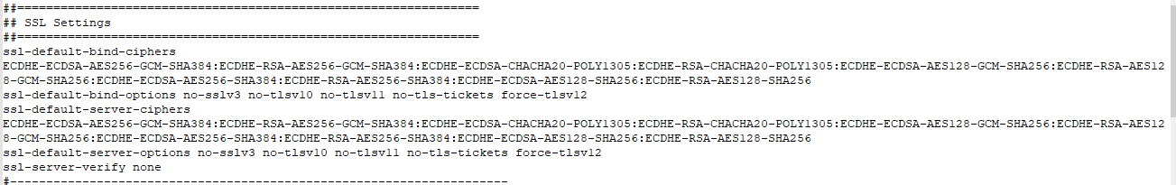

<https://www.haproxy.com/blog/haproxy-ssl-termination/>

**. Need to add port info with .pem file together**

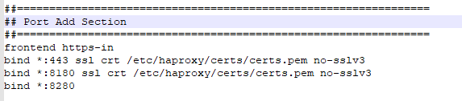

**. Need to create ACL/Frontend configuration**

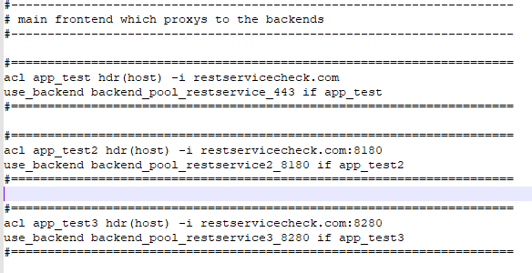

**. Need to create Backend configuration**

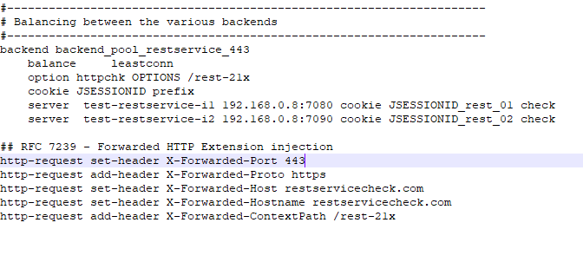



**. Here we have created the following reverse proxy service & LB using haproxy**

[https://restservicecheck.com:443/rest-21x/](https://restservicecheck.com/rest-21x/)

[https://restservicecheck.com:8180/rest-21x/](https://restservicecheck.com/rest-21x/)

[http://restservicecheck.com:8280/rest-21x/](https://restservicecheck.com/rest-21x/)

**. Verification**

<https://restservicecheck.com:443/rest-21x>

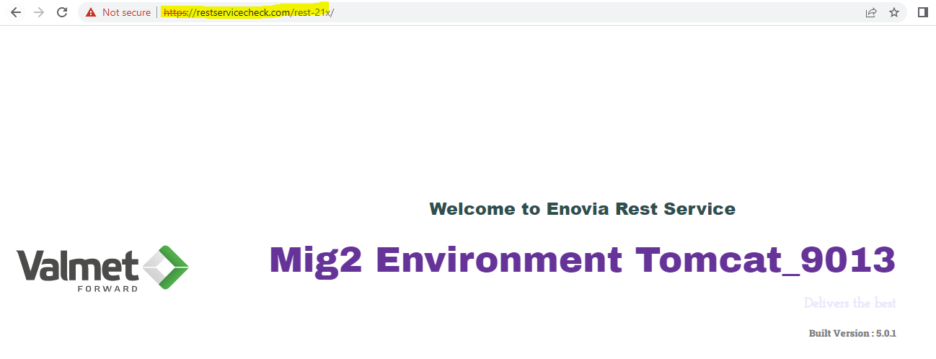

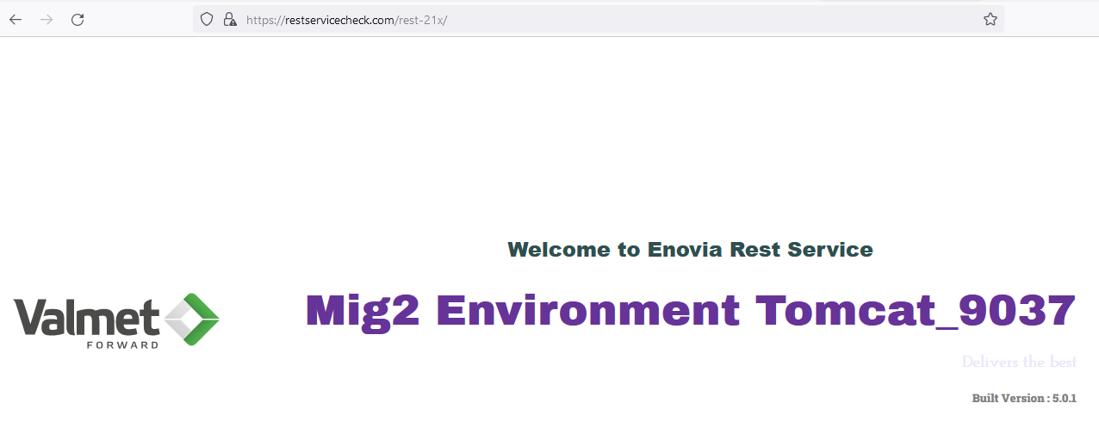

**. Load Balancing working perfectly.**

**. Haproxy Dashboard**

<http://192.168.56.113:9000/lb-stats>

